**The Relationship between Compaction, Saturation, and Iron Levels in Soil**

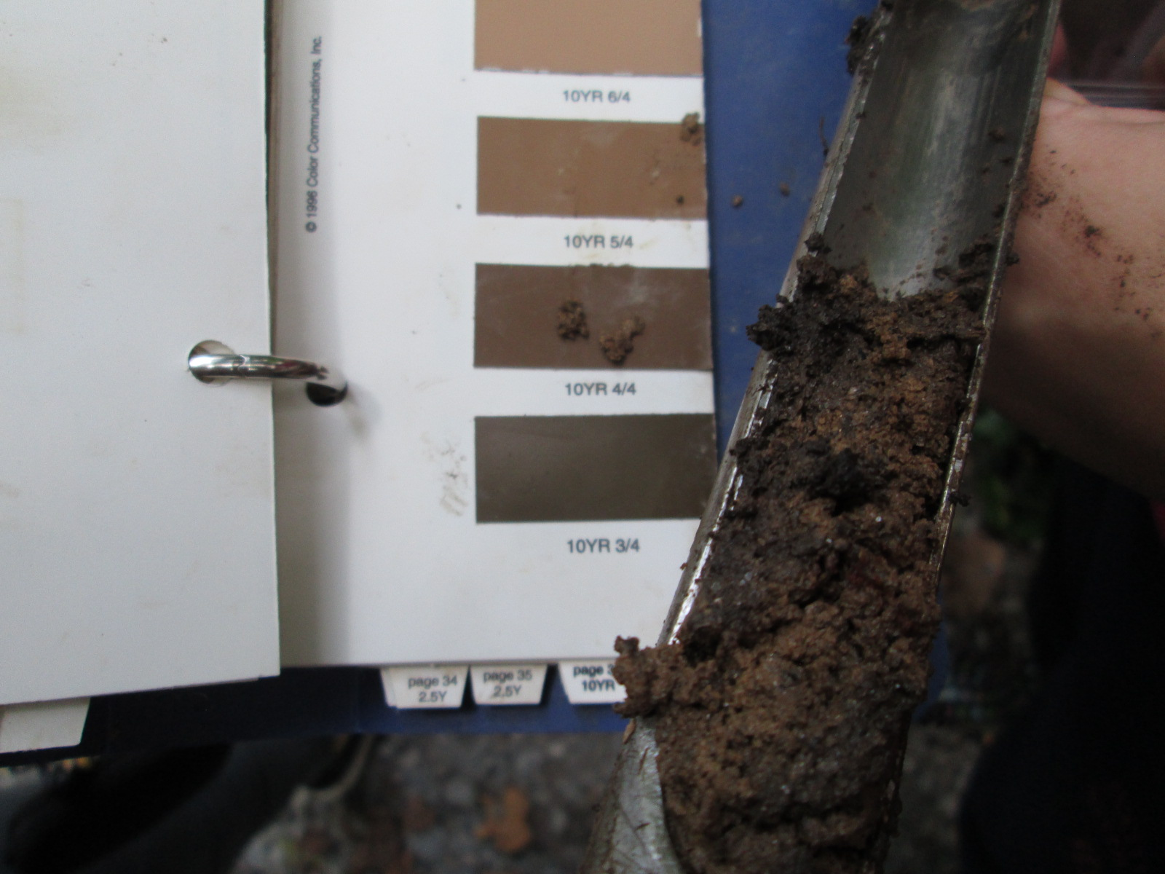

**Maddie Farrell, Oyinade Oyenusi, Grace Todd, & Emily Wayson**

**Abstract**

Iron is an essential nutrient for all plants. The amount of iron in the soil can be affected by the pH, the saturation, and compaction of the soil. In the 2016 E.S.S.R.E Soil Biota survey, it was noticed that there was an irregular amount of iron in Site 4 that did not correspond with the usual pattern that iron and pH values tend to follow. We hypothesized that the high iron content of Site 4 was caused by the saturation and compaction of the soil in that site. We tested our hypothesis by collecting three random samples from a different quadrant in each site on four different days using a soil core. From the 12 original samples that were collected each day, each one was split up based on how many horizons there were which ranged from one to three. We matched each horizon of each soil sample with a munsell value. We then tested each of these horizons for iron (ppm) using the LaMotte Model STH-14 Test Kit. Our results revealed that the compaction and saturation of the soil was the cause of the increased iron levels in E.S.S.R.E. Site 4. If we were to continue testing, we could attempt to manipulate the amount of iron in the soil by making it more saturated. This would be done by adding water to specific areas of soil and testing it before and after.

**Introduction**

Iron is an essential nutrient for all plants. It is directly involved in the process of photosynthesis, and while plants only need this element in small amounts, a lack of iron can cause diseases such as iron chlorosis which causes a plant’s leaves to turn yellow and eventually black, killing the plant’s cells and potentially the plant itself (Kuhns, M., & Koenig, R. 2016).

One thing that can impact the levels of iron available to plants is the pH of soil. How acidic the soil is determines the concentration of nutrients available for plants because most nutrients need to be dissolved by the acid in the soil to make them available for plants to use. In general, the more acidic the soil, the more nutrients are dissolved for plant use. When the pH of soil is low, there tends to be ferric iron present in the soil and vice versa when the pH is higher (Zuzek, K., & Zlesak, D. n.d.). Acidity, however, can also hurt plants. If the soil is too acidic, the plants will absorb the nutrients they need in such high concentrations that it can be “toxic to the plant” (Bickelhaupt, D. n.d.). Furthermore, if a soil is extremely acidic, vital metabolic processes in the roots cease to function and a plant simply dies.

One additional factor that can influence the iron levels in the soil is how saturated with water and how compact it is. The higher the moisture content and the more compact a soil is can increase the iron content because such soil prevents plants with smaller roots from being able to absorb more iron, resulting in a higher iron content for any other plants living there (Whiting, D., Card, A., Wilson, C., & Reeder, J., Ph.D., 2015).

Because iron is so crucial to plants and so dependent on the pH of the soil, we were puzzled when the E.S.S.R.E. 2016 Biota Survey (E.S.S.R.E. 2016) revealed that E.S.S.R.E. microclimate site 4 (N 39° 35.790, W 076° 63.897) had the highest average pH value (6.608) and also contained the highest average level of iron (24.2 ppm). After further investigation of the other 3 microclimate sites, it was noticed that in the location where the average iron content was higher, there were many more small plants, with fewer trees and large underbrush (E.S.S.R.E. 2016).  This observation led us to hypothesize that the saturation and compaction of the soil could be the cause of the irregularity in iron in these locations due to the fact that the roots of the plants living there might not be adequately able to access the iron available there (Whiting, D., Card, A., Wilson, C., & Reeder, J., Ph.D., 2015).

**Methods**

3 soil cores 15 cm deep and 2.5 cm in diameter were simultaneously collected from randomly selected locations in Quadrant 1 of E.S.S.R.E. microclimate 1 (N 39° 21.477, W 076° 38.404). This step was repeated on the same day at the same time in Quadrant 1 of microclimates 2 (N 39° 21.482, W 076° 38.3772), 3 (N 39° 21.502, W 076° 38.314), and 4 (N 39° 35.790, W 076° 63.897) for a total of 12 soil samples. Each soil core was graded using the Munsell color scale for each different horizon of soil available in a given sample (a, b, and/or c). All soil samples were then tested for ferric iron levels (ppm) using a LaMotte Model STH-14 Test Kit. The entire process was repeated each day for a total of 3 days (July 21, 2016, July 22, 2016, and July 25, 2016), making sure to collect soil from a different quadrant on each consecutive day.

**Results**

**Graph A:**

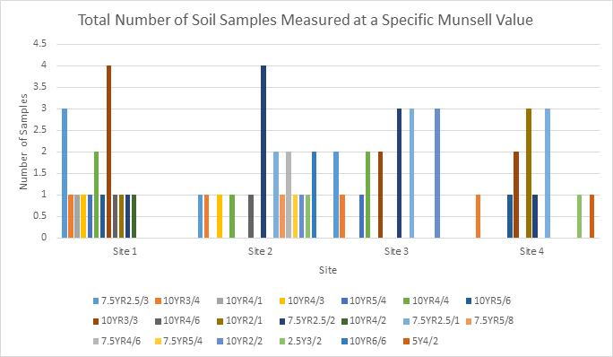

Graph A displays the number of samples taken from each site with a specific Munsell value. The saturation and compaction of the soil were measured using the Munsell scale to assign a numerical value. The darker the soil, the higher the Munsell value will be (e.g. 10YR3/4 represents a darker shade of soil than 7.5YR2.5/3), and the darker the soil, the more compact, saturated, and anaerobic it is.

**Graph B:**

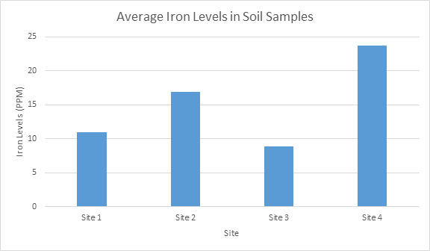

Graph B displays the average value of iron in each site in parts per million.

**Graph C:**



Graph C shows the relationship of the saturation and compaction of the soil to the amount of iron.

**Table A:**

|  |  |
| --- | --- |
| T-Test Results for Iron | |
| Sites Compared | P-Value |
| 1 and 2 | 0.58 |
| 2 and 4 | 0.53 |
| 3 and 4 | 0.02 |

**Discussion**

When comparing Graphs A and B, it can be deduced that the information collected and analyzed from Site 1 and Site 2 does not follow the hypothesized pattern. The hypothesis stated that if the saturation and compaction of the soil is high, then the iron levels in the soil will be elevated. Site 1 had many 10 Munsell values (very compact, saturated soil), yet the iron levels were low, which did not match the predicted values. Site 2 had less 10 values, and more 7.5 values (slightly looser, dryer soil), and the iron levels were high. Therefore, this data does not support the hypothesis.

On the other hand, the data collected from Site 3 and Site 4 supported the hypothesis. Site 3 had many 7.5 values, and had the lowest iron values. Site 4 had more 10 values, and the highest iron levels (see Graph C), the linear regression line (r2= 0.14) indicated that there was no statistically significant correlation.

Due to contradicting sets of data, it was decided that it was necessary to collect another day’s worth of samples to solidify the results. The current value of the linear regression coefficient (r2= 0.14) was calculated from the data collected from quadrants 1-3 in sites 1-4 and supported the values collected from sites 1 and 2, which contradicted our hypothesis. If the value of the regression coefficient of our originally collected data went down, it would lend support to the data collected from sites 3 and 4, which supported our hypothesis. The extra data from quadrant 4 in sites 1-4 brought the regression coefficient down to r2= 0.11, illustrating that a strong correlation between lower iron levels and larger Munsell scale values is even less likely to be the relationship being observed in the data.  This lends support to the hypothesis that higher Munsell values may be correlated to higher iron levels.

Furthermore, there was no statistically significant difference in the amount of iron between Site 1 and Site 2 (p= 0.58) and Site 2 and Site 4 (p= 0.53). However, there was a statistically significant difference between Site 3 and Site 4 (p= 0.02). This therefore supports the hypothesis that the levels of iron in site 4 were increased by the saturation and compaction of site 4.  Future research could include attempting to manipulate the amount of iron in the soil.  A controlled experiment could be conducted by saturating the soil with water in specific plots in each quadrant in Site 4. The soil could then be tested for iron before and after adding water. Another element that could be investigated is the root systems in Site 4. To investigate a possible correlation between plant type and iron levels, the different plants and associated root systems in each quadrant of Site 4 could be observed while simultaneously testing the iron levels in the soil.

**References**

Bickelhaupt, D. (n.d.). Soil pH: What it means.

[http://www.esf.edu/pubprog/brochure/soilph/soilph.htm](http://www.esf.edu/pubprog/brochure/soilph/soilph.htmhttp:/www.esf.edu/pubprog/brochure/soilph/soilph.htm)

Great Lakes Worm Watch. (n.d.). Sampling soils and soil characteristics.

[http://www.nrri.umn.edu/worms/team/document.html](http://www.nrri.umn.edu/worms/team/document.htmlhttp:/www.nrri.umn.edu/worms/team/document.html)

Hinkamp, D. (n.d.). Nutrients- vitamins for your soil.

[https://extension.usu.edu/files/publications/factsheet/pub__3281455.htm](https://extension.usu.edu/files/publications/factsheet/pub__3281455.htmhttps:/extension.usu.edu/files/publications/factsheet/pub__3281455.htm)

Hochmuth, G. (2011, August). Iron (Fe) nutrition in plants.

[http://edis.ifas.ufl.edu/ss555](http://edis.ifas.ufl.edu/ss555http:/edis.ifas.ufl.edu/ss555)

Kuhns, M., & Koenig, R. (2016). What is iron chlorosis and what causes it?

[http://forestry.usu.edu/htm/city-and-town/tree-care/what-is-iron-chlorosis-and-what-causes-it](http://forestry.usu.edu/htm/city-and-town/tree-care/what-is-iron-chlorosis-and-what-causes-ithttp:/forestry.usu.edu/htm/city-and-town/tree-care/what-is-iron-chlorosis-and-what-causes-it)

Whiting, D., Card, A., Wilson, C., & Reeder, J., Ph.D. (2015, October). Iron chlorosis.

http://www.ext.colostate.edu/mg/gardennotes/223.html#compaction

Zuzek, K., & Zlesak, D. (n.d.). Iron and manganese deficiencies in woody plants.

[http://www.extension.umn.edu/garden/yard-garden/trees-shrubs/iron-chlorosis/](http://www.extension.umn.edu/garden/yard-garden/trees-shrubs/iron-chlorosis/http:/www.extension.umn.edu/garden/yard-garden/trees-shrubs/iron-chlorosis/)

**Acknowledgements**

We would like to thank the following individuals for their support in our research: Mr. Brock and Ms. Dutton for supporting and teaching us throughout our three week internship; Sally Askew, Ava Drum, and Emma Wilson for their help as the program teaching assistants; and Mr. Larry Jennings for his financial support of the E.S.S.R.E. program.